1. Browse and go to this repository:

<https://github.com/Gopher-Industries/Team-Guardians/tree/TG-T12023>

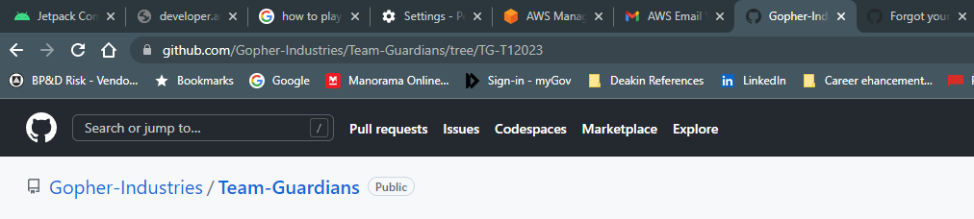

1. Copy the https link by click the – Code Tab

<https://github.com/Gopher-Industries/Team-Guardians.git>

1. Go to GitHub desktop app and take Clone a repository option from – File->Clone a repository.

Note : chose a drive from (A: or C: or D: ) from your local machine

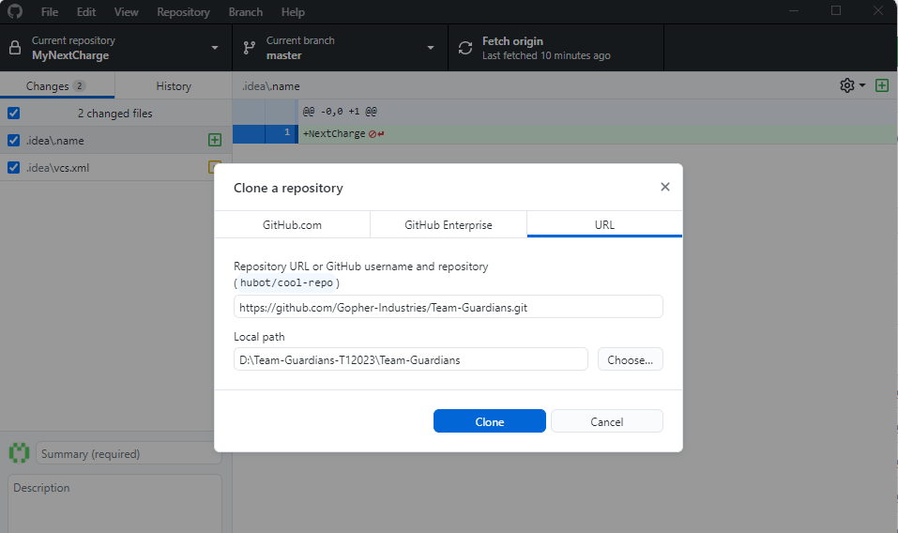

1. Select the drive from the local path in my case I select D: drive and select folder   
   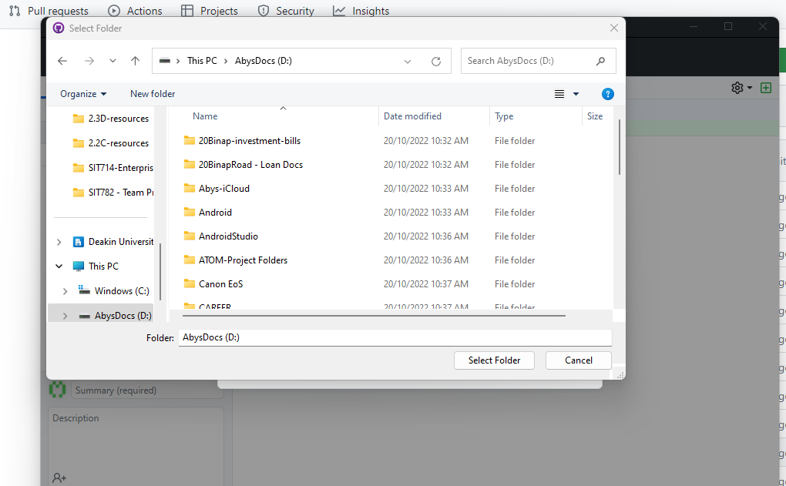

– Github app auto create the folder Team-Guardians in the in the D: drive as shown below:

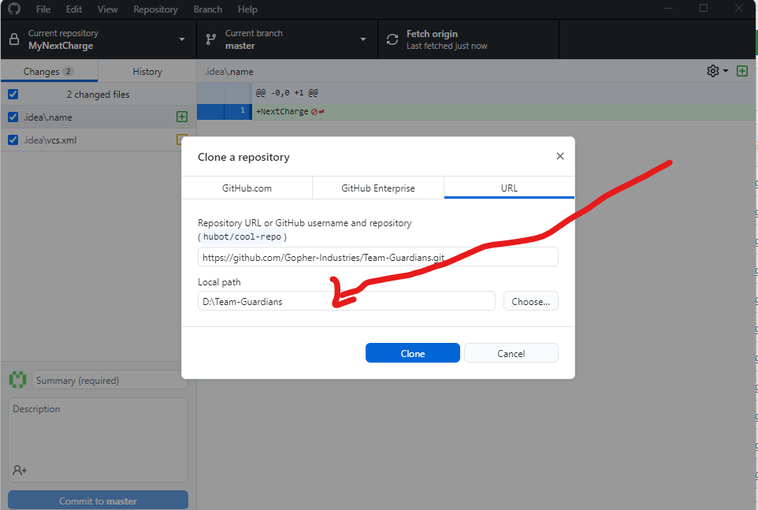

1. Now hit Clone button this create the hit hub repository in your local machine
2. Next step you need to change the branch to origin/TG-T12023
3. Now you need to find open the Team Guardians App on the Android Studio

1. Select the Team-Guardians app and click OK to load the app on your you android studio
2. Please remember to commit the change to the through GitHub app on your laptop regularly.

**All other files and folder shall be placed on the below folders:**

1. A;ll other files related - data analysis task must be added to the DataAnalysis folder and all other T1 files to be added in respective folder within OtherProjectArtefacts